Presentation Lectures
- Pipestone pipe – History
- Storytelling – fireside
- Stereotypes – The People
- Beadwork earrings
- beaded bags
- Tribal Histories - Lodges
- Migrations - Before contact
- Wild plants identification
- Tribal Spirituality – religion
- Tribal Games – varies

We think it is important to create a presentation which fits each organization, event and their participants. Please contact us with questions and ideas.

Presentation Dance
We talk about the beginnings of the pow wow, what is a pow wow today, explain regalia and dance styles. Exhibition of dance style/styles, invite audience to dance.
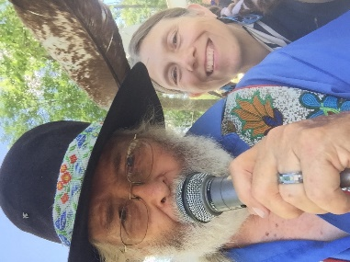
Presentation Workshops
- Pipe Making
- Stone carving: pendent
- Pipe Bag – Medicine bag
- Beadwork - Quillwork
- Moccasins – leather clothing
- Pine Needle Baskets
- Drum making
- Dream Catchers
- Pony bead animals
- Decorating a model tipi
- Camp fire cooking
- Primitive fire starting
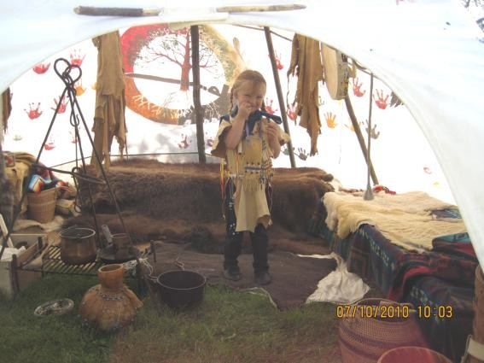

Props available for presentations
We have tipis and authentic props to decorate the inside. We want show how a lodge looked historically inside. A great way to facilitate questions and add context to stories or lectures.

Presentation
Workshop
Camp

Experience Early American Indian Culture
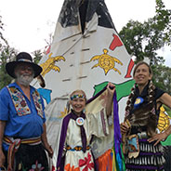

Keepers of the Sacred Tradition PO Box 24 ● Pipestone, MN 56164 1-507-825-3734 * pipe@iw.net www.pipekeepers.org

Name
Phone
Email
Date
Time

Presentation location
o Pipestone (no travel expense)
o Garretson (no travel expense)
o ____________________________
Pipestone miles to _____ X 2 = _______

 | cost | amount | total
Presenter  30-50 minute | 400.00
Per mile | 1.00
Lodging a day | 150.00
Food a day | 60.00
total
Add tipi 12” | 300.00
Props | 150.00
Total
o More than one day
Dates
Times
Call for exact prices! An estimate can be figured by taking above total, times the number of days, then add 100.00 more for each day. We hope this helps cover the many miscellaneous expenses for travel & home incurred while traveling.

 | total | days | total
Above total x
Fee x | 100.00
total

Outdoor Adventure

&

Culture Camp

Embark on a truly unique outdoor adventure with us! Discover the abundance of food and medicine all around you, learn to start a fire with flint and steel, try your hand at tomahawk throwing, experience the art of stone carving, and indulge in a delicious meal cooked over an open fire. Then, spend the night in a tipi, surrounded by the soothing sounds of crickets and wake up to the melody of birds in the morning.

But that's not all - you'll have the chance to try various activities and create your own keepsakes to take home. Each day will be filled with new experiences, adventure, and the opportunity to delve into history and culture. Sign up now and make memories that will last a lifetime!

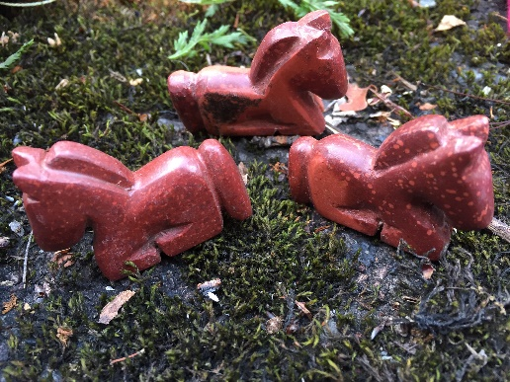

 | per | # days | total
Day camp | 125.00
overnight | 125.00
Food | 25.00
Supplies | 25.00
Total 1person

"Please note that the above estimator is intended to provide a general idea of the cost for one person for one day or overnight. However, as each camp and group is unique and tailored to specific activities and duration, we recommend reaching out to us directly to discuss the specific details and pricing for your desired experience."

